Correlatedness of interlimb coordinationas a marker of fatigue during exercise

Pablo Vázquez¹, Monika Petelczyc², Robert Hristovski³, Natàlia Balagué¹*
¹Complex Systems in Sport Research Group, Institut Nacional d’Educació Física de Catalunya (INEFC), Universitat de Barcelona, Barcelona, Spain.
²Cardiovascular Physics Group, Faculty of Physics, Warsaw University of Technology, Warsaw, Poland
³Complex Systems in Sport Research Group, Faculty of Physical Education, Sport and Health, Ss. Cyril and Methodius University, Skopje, Republic of Macedonia
* Correspondence: Corresponding Author, Laboratory X, Institute X, Department X, Organization X, Street X, City X, State XX (only USA, Canada and Australia), Zip Code, Country X.
email@uni.edu
Keywords: inter-limb coordination, synergy, fatigue, bivariate analysis.

Abstract

- Introduction

The study of exercise-induced fatigue, mostly influenced by a reductionist approach, has focused on the search of central and peripheral mechanisms reducing the muscle ability to produce sufficient force for the task under study (Gandevia, 2001;Enoka and Duchateau, 2008). Accordingly, a component – dominant, instead of interaction – dominant approach of the phenomenon (Van Orden et al., 2003), characterized by the search of quantitative biochemical markers, has dominated the investigation. Despite the overwhelming amount of research on the topic, researchers could not still reach clear conclusions about the specific mechanisms causing the limits of endurance and the fatigue-induced spontaneous task failure (Hristovski and Balagué, 2010; Balagué et al, 2014; Balagué et al, 2020).
The assumption of component-dominant of exercise-induced fatigue supposes that the variation of a single component, or process, can explain the whole variability of the measured task or performance output. The possibility that many component processes could lose or gain on significance during the developing fatigue has been hardly appreciated. A main characteristic of this component-dominant based research on muscle fatigue has been its orientation towards the study of continuous quantitative changes arising at different levels (from cells to organs), characterizing or associated with the developing fatigue. However, these continuous changes cannot, by themselves, explain the discontinuous qualitative nature of changes occurring in spontaneous task disengagement.
In order to test the general predictions of theories of self-organized change (e.g. Haken, 1978) some authors have already experimentally detected the existence of critical behavior before the spontaneous task disengagement. By analyzing the fatigue-induced changes in Fourier spectra of upper limb fluctuations, Hristovski and Balagué (2010) discovered the critical phenomenon of enhanced fluctuations in the vicinity of the spontaneous task disengagement point. Subsequently, by analysis of changes in the structure of serial correlations of upper-limb fluctuations, Vázquez et al., (2016) discovered the phenomenon of ‘critical slowing down’. Hence, it became theoretically plausible to treat the spontaneous task disengagement as belonging to the class of non-equilibrium phase transitions.
A key property of CAS is the spontaneous formation of psychobiological synergies (i.e., structural and functional coordinative structures among components) to achieve task goals (Latash, 2008). These synergies, that emerge to cope with the exercise demands, reveal the type of interactions that occur between the different components of CAS and inform about the sort of integration between them (Kugler et al., 1980). Interactions among components are hierarchically distributed in a cooperative way across different levels and timescales following the circular causality principle (Haken, 1987; Thomson and Varela, 2001; Balagué et al., 2016). This means that components and processes interact not only bottom-up, as traditionally assumed in the component-dominant approach (e.g., from biochemical to performance variables), but bottom-up and top-down (e.g., from values, motivation and attention allocation to physiological and biochemical variables and back propagate to upper levels) (see for further explanations Balagué et al., 2019).
The effort accumulation influences the control of synergies over time and hence, the different interactions between the components that form the synergy. Previous studies, following an interaction dynamics approach to exercise-induced fatigue, examined the time variability properties of a coordinative or collective kinematic variable (the elbow angle) to capture the dynamic products of interactions during a quasi-isometric exercise performed until the FISTP. Authors showed an enhancement and more rigid structure of fluctuations of the elbow angle preceding the FISTP (Vázquez et al., 2016; Hristovski and Balagué, 2010). These changes in the behavior of the formed synergy (i.e. the elbow angle) generated a critical behavior that could be ascribed to the effect of fatigue because there was no other change or modification associated to the task.
Previous researchers have shown that when holding an Olympic bar with 90º elbow flexion until the FISTP, both arms cooperate with compensatory movements and adjustments of the limbs to maintain the task and stabilize the control of the elbow angle Hristovski and Balagué, 2010; Vázquez et al., 2016). Such adaptive actions include the recruitment of additional motor units and the engagement of energy transfer from other body structures to the limbs. In particular, under competition conditions or when a real task failure is approached, a larger number of structures, from muscles to limbs are progressively engaged with effort accumulation. The increment in the number of structures cooperating to satisfy the task goal signifies a more coherent behavior in the synergy and for hence a mutually aligned (i.e. more coordinated) behavior between the limbs (Balagué et al. 2014). These findings also show the intervention of individual excitatory and inhibitory processes during exercise to allow the required adaptation and preservation of the task-goal (Vázquez at al. 2016). Such processes can only be identified when the motor task is prolonged enough while maintaining the same performance level (Vazquez et al., 2016).
While the time variability properties of coordinative variables (e.g., the elbow angle during a quasi-isometric exercise until the FISTP) have been already studied, little is known about its impact on inter-limb coordination. The way the coordination between limbs is affected by fatigue during exercise is difficult to address with traditional reductionist models and requires an interactive-dominant research approach. Several studies have been limited to analyze the interactions between limbs during maximum force production (Archontides and Fazey, 1993), in the muscle coordination during pedaling (Sato et al., 2019), or in the inter-muscular and inter-joint coordination during hammering (Côté et al., 2008). These approaches summarize the effect of fatigue during the exercise to a drop in the force production in the muscle and joints and for hence cannot explain the coordination between limbs during the exercise.

The temporal changes in the variability of complex psychobiological time series are characterized by non-stationarity, which is not captured by traditional available techniques of analysis (e.g. frequency analysis), and thus, more sophisticated methods of non-stationarity reduction are required (Amound et al., 2008). In addition, univariate approaches may have limited perspective on the complex fluctuations, which source is often unknown. The analysis of the simultaneously recorded data can be used to reveal the properties of underlying mechanisms: delays, loops, directed dependences. The multivariate studies can put the light on the identification of the structure of interactions in a system of multiple components (Müller et al., 2016). Such methods are useful for the causality assessment (in the Granger sense) and for understanding the information flow (Gencaga et al., 2015) between variables (by Shannon formalism). Running Correlation Function and Bivariate Phase-Rectified Signal Averaging (Bauer et al., 2010) methods can be used to study the interrelations between two time series recorded simultaneously. The analysis is dedicated to assessment of the magnitudes (strength) of temporal interrelations to reflect the fatigue development during the task.
The aim of this study was to investigate the effect of exercise-induced fatigue on the upper inter-limb coordination during a quasi-isometric exercise performed until exhaustion.
Materials and Methods
  - Participants

Seven voluntary physical education students (4 females and 3 males M=22,41 years old, SD=1.2) participated in the study. All participants were familiar to strength training and conditioning. Prior to taking part in the study, they completed a questionnaire to confirm their health status. All the experimental procedures were explained to the participants before they gave their written consent for the experiment. The Local Research Ethics Committee approved the study (072015CEICEGC) according to Helsinki Declaration.

  - Procedure

On three different days over a period of three weeks (one day per week), participants performed a quasi– isometric test holding an Olympic bar in an arm curl position following the instructions described in Vázquez et al., (2016) until the FISTP. According to these authors, participants were encouraged to maintain intentionally a 90º angle at their elbow joint during the task even if the initial elbow angle was lost. One week prior to start the study, participants performed a one-repetition maximum (1RM) test (M=33,43 kg, SD=3,16) to determine the maximum weight that they were able to move on a complete arm-curl exercise. Then, the 80% of the weight used in the1RM was calculated for each participant and used for the load in the exercise. During the three trials participants sat on an inclined-forward bench in order to prevent possible spinal injuries and a reference cord was placed at the level of the participant’s wrist in order to facilitate haptic and visual feedback on the initial position and its loss. Prior to the exercise the bench position and the reference cord were adjusted for each participant on every trial. The elbows of the participants were not fixed letting them to freely vary in all three dimensions. To record the elbow angle variations an electrogoniometer (Biometrics) was placed in the elbow. The sensors of the electrogoniometer were placed on marked points on the upper arm and forearm for both arms and were adjusted to the required starting flexion of 90º. The elbow angle variations were recorded using Ebiom software for further analysis. The sampling frequency was set at 50 Hz and the amplitude resolution was 0.1 deg. for each extremity. Figure 1 shows an example of the variations in the one’s subject elbow angle degrees recorded during the trials.

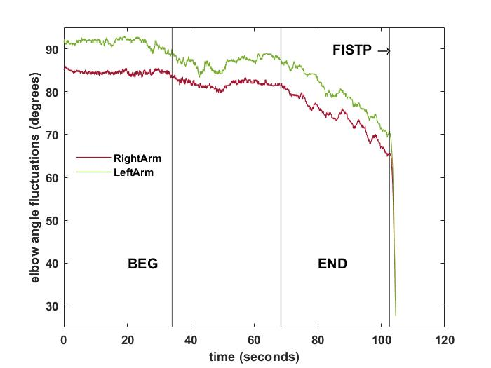

Figure 1.

Data Preprocessing
The proper correlation analysis requires trends reduction, while it is sensitive to long lasting transitions observed due to the inability to maintain a task performance criterion (to sustain the elbow angle at 90°). In the beginning the fatigue-induced spontaneous termination point (FISTP) (Hristovski and Balagué, 2010) was determined in the datasets. The FISTP was estimated from differentiated time series, where persistent change toward negative values was obtained (Vázquez et al., 2016). This negative trend was determined from linear fit performed in overlapping windows with length 50 points starting from the end of the recording. FISTP was found in time series from both elbows separately. In case of any divergence between its position in left (L) and right (R) datasets, the FISTP was set for the earlier position in time. Finally signals from both elbows after FISTP determination has the same length.
In the next step, the linear trend was removed. For each signal the first order polynomial fit was performed separately. After this procedure, the detrended recordings were raised by the minimum of original data to obtain the referential values of elbow angle.
The fatigue development is in timeline observed, however the task length to failure occurrence is different between subjects. Therefore to quantify fatigue’s progress, the recordings were divided into unified segments, which reflected the percentage of time evolution preceding the FISTP. For comparison purposes the first 30% (BEG) and the last 30% (END) of the preprocessed data were selected for the further analysis.

Running correlation function
In the study, correlation function was applied to selected segments. For all calculations common procedure of overlapping windows was performed. Correlation coefficient was determined in predefined window length W. Then, the window was moved one point forward through time series and the correlation coefficient was determined again. The procedure was repeated until the window reached the end of selected data segment (BEG and END separately). Described sliding approach for the temporal correlation coefficient determination is known as running correlation function (RCF). To obtain the limited ranges of RCF values varying between -1 and +1, the normalization by local standard deviations σ_{R}(n) and σ_{L}(n)was proposed:
$RCF\left(n\right)=\frac{\sum_{i=1}^{W}{\left(L_{n+i}-μ_{L}\left(n\right)\right)∙\left(R_{n+i}-μ_{R}\left(n\right)\right)}}{\left(W-1\right)∙σ_{L}\left(n\right)∙σ_{R}\left(n\right)}$ (1)
In the Equation (1),μ_{L}(n) and μ_{R}(n)refers to local mean determined for left and right elbow respectively. Note however, the means and standard deviations in Equation (1) were calculated only for current window, which left limit is n-th data point in the time series segment. Five windows were selected for the analysis W={50,100,150, 200, 250, 300}, which are multiplicities of 1sec due to experimental sampling rate. Finally, we decided to verify the delays in the correlations. It was obtained by introduction of time lag τ in the Equation (1). The range of τ depends on window width W. The maximal τ was set for each case at W/2.In such realization the current windows in both signals overlapped.
For the statistical comparison BEG and END segments the analysis of RCF distributions was proposed. The RCF is given in the constant range <-1;1> and the number of data points in BEG and END is the same. The analysis of the correlations relies on its magnitudes in selected segments. We proposed a marker, which reflects high correlations within left and right arm. Therefore we calculated the percentage of the RCF values which follow the rule: RCF(n)>0.8 in BEG and END separately. It is denoted as %RCF>0.8. Note, that constant number of data points in BEG and END segments causes that the results for each individual are not sensitive to the length of the signal.

Bivariate phase rectified signal averaging (BPRSA) method
Originally, the method was used for the assessment the baroreflex sensitivity (Bauer et al., 2010). In general however, it can be easily applied for the estimation of the interrelations between two simultaneously recorded data. One recording is treated as trigger and the second is a target, thus the method can be used to estimate the directed coupling. The BPRSA computation process is divided in five successive steps. 1) Anchor points are denoted in the trigger signal and reflected in the target signal at synchronous position in time. Anchor points are defined as values in the trigger signal, which are larger than the previous one. 2) Segments are selected in the target signal around anchor points. All segments are the same length and equal to widow W, which was used in the RCF analysis. The values of the target signal given in the segments are indexes in the range from -W/2 to +W/2. The segments usually overlap. 3) Segments are aligned at anchors of target signal. 4) Averaging within the aligned segments is performed. In result, one oscillating BPRSA signal X is obtained. It reflects the common (and averaged) effects of dynamics in the target signal, which are caused by the increase in the trigger signal. The BPRSA signal X consists of fluctuations in the target signal preceding and following of this increase. 5) Finally, the marker for BPRSA is determined from four points indexed in the segment by i={-2,-1,0,1}:
${BPRSA}_{trigger→target}=\frac{X\left(0\right)+X\left(1\right)-X\left(-1\right)-X(-2)}{4}$ (2)
Points of target signal X(-1), X(-2), X(1) surrounds the increase in the trigger signal in time. The increase reflected in the target signal is positioned in an anchor X(0). It is possible to show, the effect of the trigger in the target signal by introducing the normalization (Müller et al., 2012). Normalization is obtained from average of the increments in the target signal, which was used for anchor definition. In result, the BPRSA coefficient (2) is obtained in the units of target divided by units of trigger. In our case, both signals are in degrees, thus determined marker is unitless. We performed computations in both possible directions: from right (trigger) to left (target) arm and in opposite way. Note that this approach can be used to assess the directed interrelation between variables. However, the proposed analysis is used to support the symmetric properties of the coordination represented by RCF. Therefore we propose a unique marker, which reflects both: the symmetric properties of interrelations and quantification of their magnitude. First, the differences in the BPRSA analysis between the arms, i.e. the difference between the BPRSA (right over left) minus the BPRSA (left over right): diff(BPRSA)= BPRSA_{R->L} – BPRSA_{L->R}are calculated. In the next step, for the differences, we estimated the ranges between 5th and 95th centiles of diff(BPRSA) values for BEG segment. We determined the diff(BPRSA) for ENG values that exceed the centile limits given in BEG and present them in percentages. This variable is denoted as %Range(END-BEG). Assuming larger variations in END segment than in BEG, the expecting percentages of %Range(END-BEG) should exceed 10%. Not that in such approach, the sign of the diff(BPRSA) parameter is not taken into account and can be treated as symmetric measure of the magnitude of interrelation between data.

- Results
The results are divided in two sections. In the first one, we present the analysis of the window length in the RCF and BRPSA calculus (Table 1 and Figures 1-3). On the second part, the influence of the time lag is discussed (Figure 4). In both cases, the calculations were done for BEG and END segments separately.
In Figure 1, the RCF and its distributions in selected window W=150 are presented for one subject. Each point in the plot of RCF (Figure 1 A) corresponds to correlation coefficient determined for left and right arms datasets in sliding window. Figure 1 B and C are the histograms of RCF from BEG and END segments. According to marker introduced in Sec. 2.4: %RCF>0.8 for BEG equals 4.6%, while for END is 55.1%. It was determined for each subject and then the statistics of the group were performed to reflect the common properties of the RCF found in BEG and END segments.
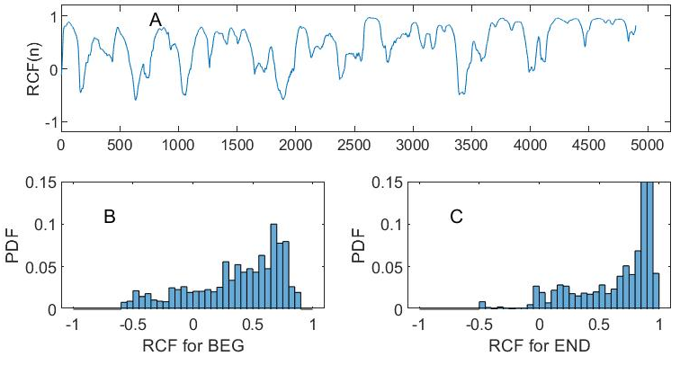
Figure 1: (A) The RCF plot for dataset until FISTP for one representational subject with no time lag and window W=150. The probability distributions for BEG and END are given in (B) and (C) respectively. For better visualization the distributions were constructed with constant number of bins equals 40.
In Table 1, the means of % RCF>0.8 with SD are presented for the windows 50, 100, 150, 200, 250 and 300. The mean for BEG segment increases with window length while for END segment, the means reaches the maximum (for W=200) and for next windows (W= 250 and 300) starts to decrease. In both fragments, the SD values increases with W, but the magnitude for END segment is larger in comparison to BEG segment. The coefficient of variation CV is also determined. CV for BEG segment is not sensitive to the windows length (very small fluctuations in the third row in the Table 1), but CV for END can be characterized by increasing trend with windows enlargement. Note that in the latter case, the CV for W=300 is twice larger than for W=50, which can be mainly explained by the magnitude of SD. It is observed that in the BEG segment the fluctuations are stable, but for the last segment of the exercise (END) the variation increases with windows width.
Table 1. The mean, SD and CV of %RCF>0.8 for different windows W.
Windows | 50 | 100 | 150 | 200 | 250 | 300
Mean BEG | 7,49 | 10,53 | 12,50 | 13,59 | 15,84 | 17,03
SD BEG | 6,24 | 9,12 | 10,84 | 11,82 | 12,88 | 14,28
CV BEG | 83,4 | 86,6 | 86,7 | 87,0 | 81,3 | 83,8
Mean END | 17,00 | 26,98 | 28,94 | 29,46 | 28,20 | 27,05
SD END | 8,07 | 14,94 | 19,44 | 21,96 | 23,63 | 25,24
CV END | 47,5 | 55,4 | 67,2 | 74,5 | 83,8 | 93,3
To support the results of RCF and its variations in BEG and END segments (Table 1) the product $σ_{L}\left(n\right)∙σ_{R}\left(n\right)$in windows were analyzed (comparing the denominator in Equation 1). As it is observed in the Figure 2, it increases with the W in the BEG segment (W50=0.19; W100=0.35; W150=0.46; W200=0.55; W250=0.63; W300=0,70), however the effect is much stronger for END segment (W50=0.29; W100=0.69; W150=1.07; W200=1.38; W250=1.64; W300=1.80).
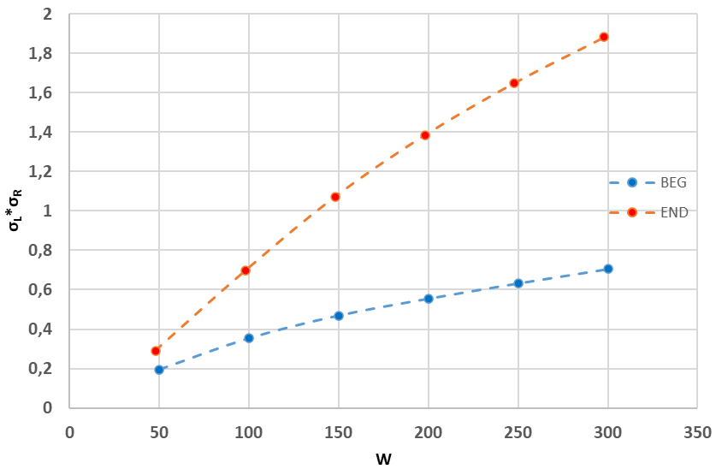
Figure 2: The results of mean product $σ_{L}\left(n\right)∙σ_{R}\left(n\right)$obtained for BEG and END segments respectively taking into account increasing window width W. The calculus was performed in the same manner as for RCF from Table 1.

The results for the bivariate BPRSA analysis are similar than the RCF and are presented in Figure 3. In Figure 3 the influence of the right arm over the left and the left arm over the right in a selected window W=300 are presented for one subject. It is observed that the influence between the arms increased in the last part of the exercise corresponding to the END segment and they follow almost the same pattern specially close to FISTP.
The values of the change percentage, % Range (END-BEG), between segments and its SD were calculated for each window (W50=16.01; W100=20,22; W150=23.83; W200=25.94; W250=25.92; W300=29.31). In the Figure 4 it is observed that the mean percentage of %Range (END-BEG) exceeds 10% for all windows.
When %Range(END-BEG) exceeds 10%, the END segment is characterized by larger magnitude of BPRSA differences than BEG. It can be interpreted as occurrence of increasing interrelation between arms in the last segment of effort in comparison to initial phase of experiment. SD in Figure 3 confirms large variability between subjects in BPRSA determination. These results are in line with the increment obtained in the %RCF>0.8 (Table 1).

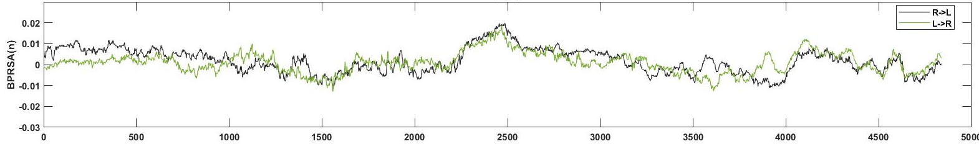
Figure 3. The BPRSA plot for dataset until FISTP for one representational subject with no time lag and window W=300. It is observed an increment in the interrelation between arms in the last part of the time series.

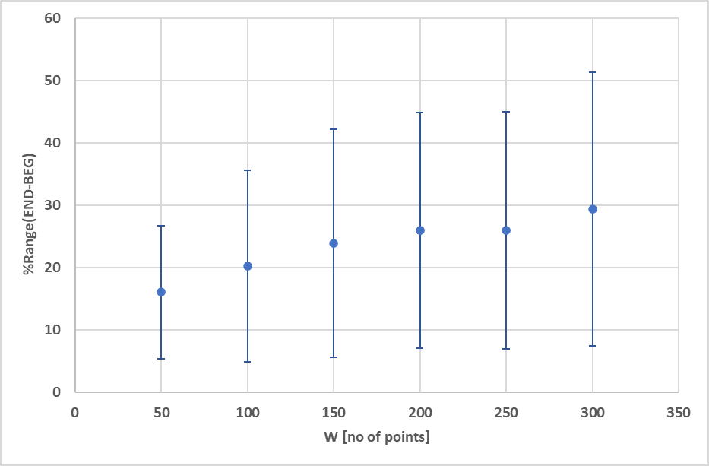
Figure 4: The mean of %Range(END-BEG) determined taking into account different length of windows (W=50, 100, 150, 200, 250 and 300). The percentages characterizing END segments increase with window length. Error bars represent the standard deviation (SD).
Taking into account the maximum observed for means of % RCF > 0.8 in END segment (Table 1), we focused on the selected window W=150 and introduced the time lags in correlation determination (Figure 5). There is a decreasing profile of %RCF>0.8 with time lag for both segments. However, the larger effect of decrease is for END segment (with a relative change of 20,4) than for BEG segment (with a relative change of 11,2). Note that the mean of %RCF>0.8 is smaller than 10%for time lags > 30.The decrease of SD in BEG and END segments is also observed.

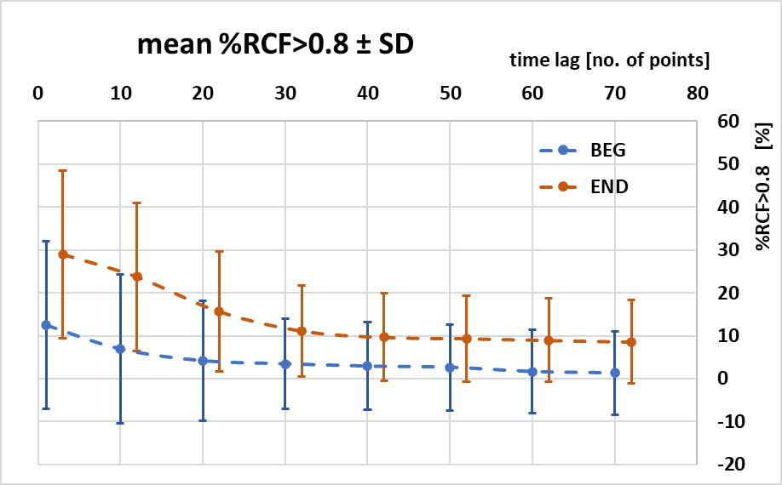
Figure 5: The mean %RCF>0.8 for BEG and END data sets with increasing time lags τ =0, 10, 20, …,70. The constant window length W=150 is used. END results are shifted and dotted line is plotted to visualize the trend. Error bars represent the standard deviation.
- Discussion

Inter-limb coordination during a quasi-isometric exercise performed with upper extremities until exhaustion has been studied. The results showed an increment in the correlation between both arms when comparing the initial 30% (BEG) and final 30% (END) segments of the electrogoniometry time series for different time windows. We considered two different analyses, on one hand, a univariate analysis (corresponding to RCF) and on another hand a bivariate analysis (corresponding to BPRSA), in both analyses it is observed a common increment in the high correlation magnitude values between the BEG and the END segments for different analyzed windows. The findings also indicate that the level of correlations was higher on shorter timescales. Based on the task goal stabilizing synergy approach (Kelso, 2009; Haken, 2013), the increase in the inter-limb correlation, and hence in the coordination during the final segments, revealed lower inter-limb independence. This is related to the impaired ability of the psychobiological system to maintain its independent control during a task performed until exhaustion (Vázquez et al, 2016).

Our results showed an enhancement of the correlation in the END segment compared to the BEG in both arms. This difference between the two segments means that any variation in one of the arms is more probable to be associated with a variation in the same direction by the other arm. This is well observed by the values in the %Range(END-BEG) and RCF>0.8 (Figures 2 and 4) which indicate that the lower correlation of high magnitude and less influence between the arms were found in the BEG segment, On the contrary, the higher values were found in the END segment showing greater influence between the arms and hence more correlation of high magnitude.
These results show a similar development of fatigue in both limbs and are in line with the previously reported by Hristovski and Balagué (2010) and Vázquez et al., (2016) supporting the hypothesis of the task goal stabilizing synergy spread over long time periods. In both studies, the authors observed that fatigue has an important role in the control of the exercise. Fatigue is dealt with as the inhibitory, protective mechanism in competition with the activation, excitatory processes at the neuromuscular level (Hristovski and Balagué, 2010). In our study, this competition between the intention to sustain the Olympic bar (activation process) and the loss of muscular tension (protective, inhibitory process) was illustrated by the increments in the elbow angle fluctuations during the last segment of the exercise. Whereas in the BEG segment these processes competed over shorter time scales resulting in a stabilizing effect (i.e. small fluctuations around the task goal), as the exercise proceeded they competed over longer time scales (i.e. the subjects needed larger periods to recover the initial elbow angle). This general mechanism explained the presence of negative feedback loops where any small positive deviation as a consequence of central excitation was compensated by a subsequent negative fluctuation as a result of the coupling between the inhibition mechanism and the pull of gravity (Balagué et al, 2013; Vázquez et al., 2016; Montull et al., 2020). In consequence, as fatigue developed, the neural, metabolic, and muscular changes were reflected by lower muscle contractile ability and provoked a larger inhibitory effect. Thus, the accumulated effort increased the inhibitory mechanisms, that became macroscopic, and the influence between both arms became more coherent. To maintain the exercise, the subjects had to intentionally activate an increasing number of motor units losing their initial stability progressively. As a result of this process, the mutual dependence of both limbs increased with the development of fatigue reflecting the impaired ability of the system to separately control its degrees of freedom.
The results in the correlation magnitude values also revealed that the size of the fluctuations was lower during BEG compared to END segment, meaning that the corrections made by the subjects to control the 90º elbow angle were small and the mutual independence between both arms was maintained for this segment. On the contrary, the values of the correlation magnitude in the END segment were higher pointing to larger deviations in the elbow angle from the task goal (maintain 90º) represented by the higher SD values. It was also observed that for larger windows, the magnitudes of SD indicate variability of %RCF>0.8 and %Range(END-BEG) within the segments, which are especially large for END segment. This could point to the larger deviations of elbow angle close to the FISTP, and reflected the critical behavior just before it (Hristovski and Balagué, 2010). Furthermore, the results of the CV showed a constant mean increase with window enlargement, suggesting the preservation of correlation between left and right arms in the BEG segment when the impact of fatigue development was low. On the contrary, the correlation magnitude was larger for END in all the studied windows. Our findings corroborate the previous observations made by Hristovski and Balagué (2010) where the authors shown that the larger fluctuations (i.e. deviations from the initial elbow angle) increased in the last part of the exercise showing higher variability in the subjects close to the task disengagement. According to the authors, the enhancement in the elbow-angle variability is related to an increasing exploratory activity of the neuromuscular system as a result of the initial elbow-angle stability destabilization provoked by the development of fatigue.
The time lags introduced in the analysis corroborate the last observations and indicate that the high level of correlations between left and right arms measured by %RCF>0.8 are short term, and is confirmed by sudden drop observed for time lag < 40. This higher magnitude in time lag < 40 reflected the quick adjustments and reconfigurations made by subjects to maintain the task goal. However, we observed that for the longer time lags (τ= 50, 60, 70) the %RCF>0.8 decreased very slowly and was characterized by smaller SD. These findings support the notion that the correlation between limbs is observed and produced over shorter time scales, due to the small adjustments that the subjects made to maintain the elbow angle. However, this effect was not observed for larger lags.

In other words, the dynamics within the upper limb system became increasingly critical, pointing towards a mutually aligned, more coherent behavior between the cooperative and competitive processes within the neuromuscular axis (Balagué et al., 2014). The smaller magnitudes of RCF and BPRSA for BEG segment meant a potential for more independent and flexible spatio-temporal control of the coordinative variable, i.e. elbow angle, (Vázquez et al, 2016). On the contrary, the higher values of the %RCF>0.8 and higher percentage in the %Range(END-BEG) for END indicated a more coherent and hence more rigid control of the task. We demonstrate that close to exhaustion, the inter-limb system becomes excessively coupled compared to beginning of the exercise where the independent, more refined, control of the upper limbs is possible. Furthermore, the enhancement in the correlation and mutual dependence between the arms can be proposed as a new marker of the approaching exhaustion.

The results of this study can help to understand the dynamics in the correlation between different systems under the presence of constraints, and strengthen previous research findings about the different strategies that participants use to negotiate with fatigue. Our findings demonstrate that the development of fatigue cannot be explained by simple, component-dominant approaches but integrative, network interaction-dominant approach of the phenomenon. However, caution should be taken in the interpretation of the results because the values of the SD found in the larger windows warn that the last observation is only valid for lower windows width (<200). The higher amplitude in the elbow angle fluctuations during the last part of the exercise observed in the time series and the different strategies made by the subjects to maintain the exercise until the FISTP could explain this observation. In the context of the complex systems, further investigations are needed to study how the correlation between different psychobiological signals is modified due to effort accumulation.

Conclusions
The study reveals an increment of the inter-limb coherence of upper extremities during a quasi-isometric exercise performed until the FISTP. The bivariate analyses showed that the developed fatigue influenced the coordination between the arms resulting on a loss of their initial autonomy to control the task. The enhancement of the inter-limb coordination at the end of the exercise showed a more aligned, mutually influenced, behavior between the limbs as a consequence of the developed fatigue. The results also point towards the use of bivariate methods of analyses to assess the correlation between different psychobiological signals that fluctuate during the exercise.
Acknowledgments
This is a short text to acknowledge the contributions of specific colleagues, institutions, or agencies that aided the efforts of the authors.
Funding: Details of all funding sources should be provided, including grant numbers if applicable. Please ensure to add all necessary funding information, as after publication this is no longer possible.
References
Amoud, H., Snoussi, H., Hewson, D., and Duchêne, J. (2008). Univariate and bivariate empirical mode decomposition for postural stability analysis. EURASIP J. Adv.Sig. Proc, 65, 73-91, doi:10.1155/2008/657391
Archotides, C., and Fazey, J.A. (1993). Interlimb interactions and constraints in the expression of máximum forcé: A revie, some implications and suggested undelying mechanisms. J. Spor. Sci.11, 145-158.
Balagué, N., Hristovski, R., Vainoras, A., Vázquez, P., and Aragonés, D. (2014). Psychobiological integration during exercise. In Complex Systems in Sport, eds. K. Davids, R. Hirsitovski, D. Araújo, N. Balagué, C. Button, and P. Passos ( New York, NY: Routedgle), 62–81.
Balagué, N., Pol, R., Torrents, C., Ric, A., and Hristovski, R. (2019). On the relatedness and nestedness of constraints. Spor. Med. Open. 5(1). doi: 10.1186/s40798-019-0178-z
Bauer, A., Morley-Davies, A., Barthel, P., Müller, A., Ulm, K., Malik, M., and Schmidt, G. (2010). Bivariate phase-rectified signal averaging for assessment of spontaneous baroflex sensitivity: pilot study of the technology. J.Electrocardiol.43, 649-653. doi: 10.1016/j.jelectrocard.2010.05.012
Côté, J.N. Feldman, A.G., Mathieu, P.A. and Levin, M. (2008). Effects of fatigue on intermuscular coordination during repetitve hammering. Mot. Cont. 12, 79-92. doi:10.1123/mcj.12.2.79.
Cuomo, V., Lanfredi, M., Lapenna, V., Macchiato, M., Ragosta, M., and Telesca, L. (2000). Antipersistent dynamics in short time scale variability of self-potential signals. Ann.Geophy.43, 271–278. doi:10.4401/ag-3644
Gencaga, D., Knuth, K, H., Rossow, W,B. (2015). A recipe for the estimation of information flow in a dynamical system. Entropy. 17, 438-470; doi:10.3390/e17010438
Haken,H. (1987). Synergetics: an approach to self-organization in self-organizing Systems. The emergence of order. In Life Scientific Monografics., ed. F.E. Yates. (New York: Plenum), 417–34.
Haken, H. (2013). Synergetics: Introduction and advanced topics. Springer Science & Business Media.
Hristovski, R., and Balagué, N. (2010). Fatigue-induced spontaneous termination point–Nonequilibrium phase transitions and critical behavior in quasi-isometric exertion. Hum. Mov. Sci. 29, 483–493. doi: 10.1016/j.humov.2010.05.004
Kelso, J. A. S. (2009). Synergies: atoms ofbrain and behavior. In Progress in Motor Control, ed. D. Sternad (NewYork, NY: Springer Science-Business Media, LLC), 83–91
Kugler, N. P., Kelso, J. A. S., and Turvey, M. T. (1980). On the concept of coordinative structures as dissipative structures: I. Theoretical lines of convergence. In Tutorials in Motor Behavior, ed. G. E. Stelmach and J. Requin (New York, NY: North-Holland), 3–47.
Montull, L., Vázquez, P., Rocas, L., Hristovski, R., and Balagué, N. (2020) Flow as an Embodied State. Informed Awareness of Slackline Walking. Front. Psychol. 10:2993. doi: 10.3389/fpsyg.2019.02993
Müller, A.,Morley-Davies, A., Barthel, P., Hnatkova, K., Bauer, A., Ulm, K., Malik, M., Schmidt, G. (2012). Bivariate phase-rectified signal averaging for assessment of spontaneous barorreflex sensitivity: normalization of the results. J. Electrocardiol.45,77-81. doi: 10.1016/j.jelectrocard.2011.07.010
Pol, R., Hristovski, R., Medina, D., and Balagué, N. (2018). From micro-to macroscopic sports injuries. Applying the complex dynamic systems approach to sports medicine- A narrative review. Bri. J. Sp. Med.53(19), 1214-1220. doi: 10.1136/bjsports-2016-097395.
Shew, W. L., Yang, H., Petermann, T., Roy, R., and Plenz, D. (2009). Neuronal avalanches imply maximum dynamic range in cortical networks at criticality. J. Neurosci.29, 15595–15600. doi: 10.1523/JNEUROSCI.3864-09.2009
Shu, Y., Hasenstaub, A., and McCormick, D. A. (2003). Turning on and off recurrent balanced cortical activity. Nature. 423, 288–293. doi: 10.1038/nature01616
Thompson E., and Varela F. (2001). Radical embodiment: neuronal dynamics and consciousness. Trend. Cog. Sci. 5, 418–425. doi:10.1016/S1364-6613(00)01750-2

Van Orden, G. C., Moreno, M. A., and Holden, J. G. (2003). A proper metaphysicsfor cognitive performance. Nonlin. Dyn. Psychol. Life Sci. 7, 49–60. doi: 10.1023/A:1020462025387
Vázquez, P., Hristovski, R., and Balagué, N. (2016). The path to exhaustion. Time-variability properties of coordinative variables during continuous exercise. Front.Physiol. 7:37. doi: 10.3389/fphys.2016. 00037

